**Power BI Installation Documentation**

Power BI that Microsoft created in 2015 that might be helpful toward creating a collaborative environment in which any stakeholder of the budgeting process can share his findings with others, working together on the goal.

Power BI is a suite of business analytics tools that deliver insights throughout your organization. Connect to hundreds of data sources, simplify data prep, and drive ad hoc analysis. Produce beautiful reports, then publish them for your organization to consume on the web and across mobile devices. Everyone can create personalized dashboards with a unique, 360-degree view of their business. And scale across the enterprise, with governance and security built-in.

Power BI has offered two types of services to develop the Reports

1) Power Bi Desktop 2) Power Bi Cloud

Power BI Desktop and Power BI are two sides of the same coin: Power BI Desktop is a Windows application running on your PC, whereas Power BI is a cloud service that you use through the web browser. In both cases, you will be able to perform the same operations, albeit with some subtle differences. Moreover, the two tools complement each other, and you are likely to use both to build your dashboards.

Power BI is a web service to which you can upload data and build insightful dashboards and charts. As with any web service, you need to sign in, but Power BI does not require much in the way of credentials: to get started, all you need is a valid email address

**The below figure shows the Power bi Welcome Page Browser :-**

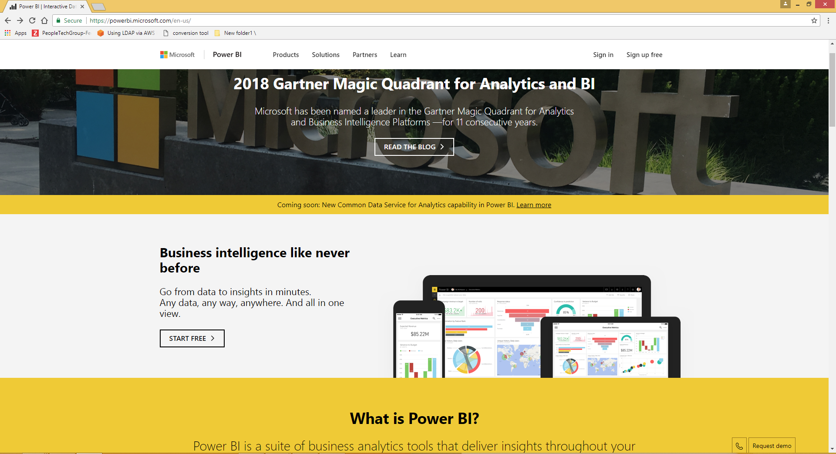

After Opening the welcome web page you have to sign up the power bi by using valid email id as shown in the below figure

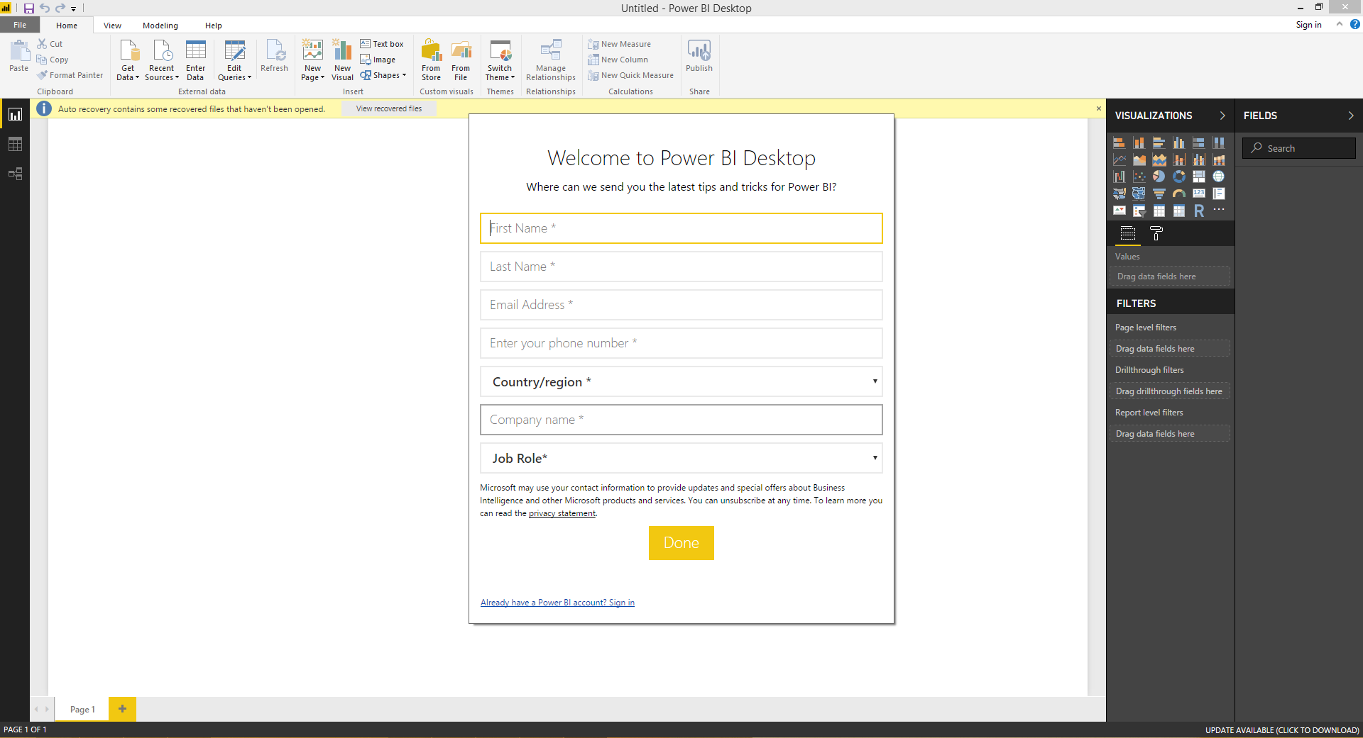

The completing the above process then sign in the power-bi page

1) Download the Power-bi desktop and install after completing the reports we have to publish the reports in power bi cloud by giving Email id and Password you gave when signup process.

2) By completing the Report when click on the publish button as shown in the below figure

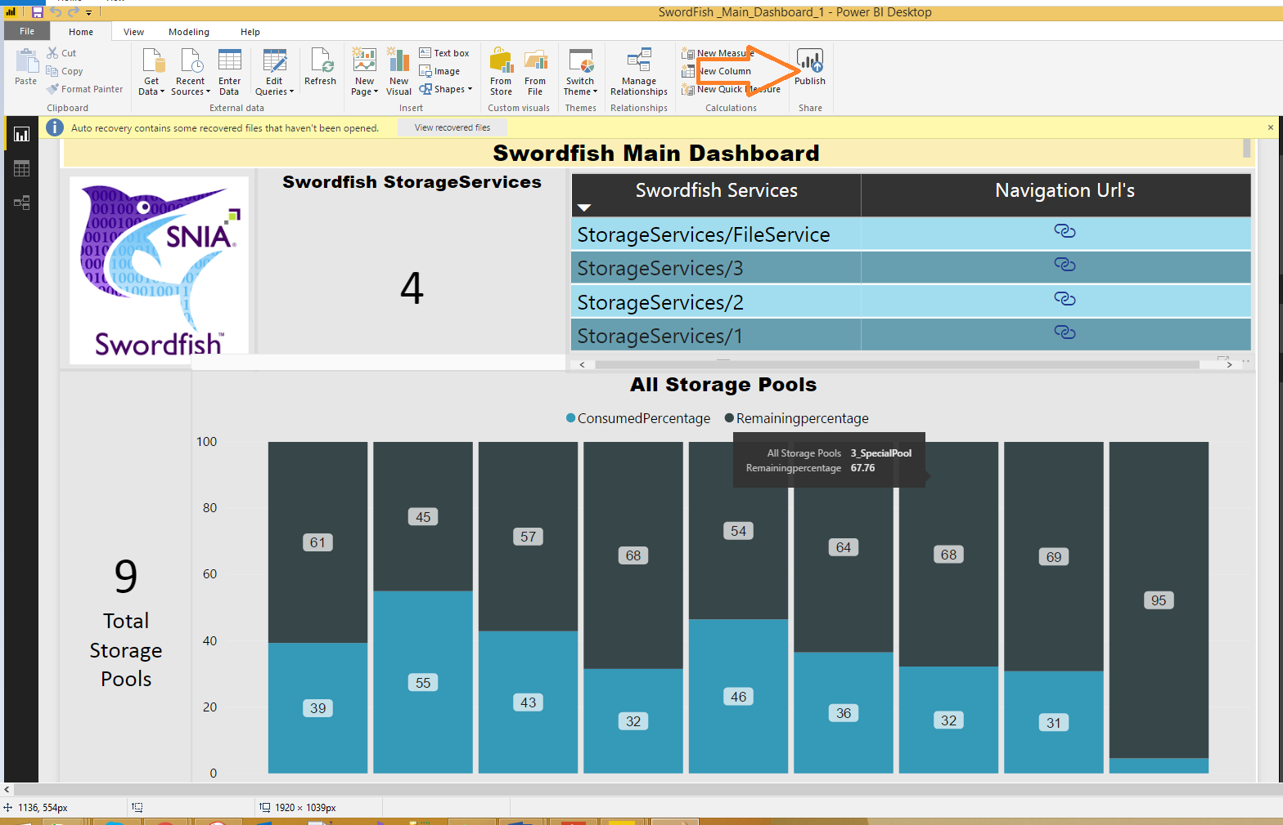

After publishing the reports we can see the reports in cloud environment

When we see those reports go to the web browser and click on [www.powerbi.microsoft.com](http://www.powerbi.microsoft.com)

Sign in by using your email-id and Password

When going to the power-bi Report server The main page will be as shown in the below figure

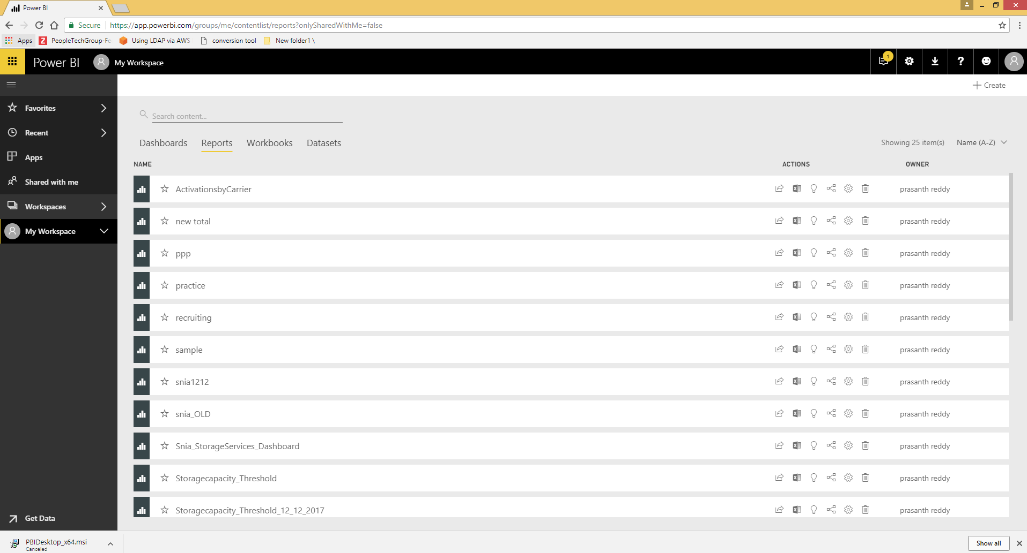

All published reports will be saved here and share the Dashboards to any one and if u have any Naming convention errors we change here also by edit the reports

When we share the reports any one on the internet go the file menu and click on publish to web

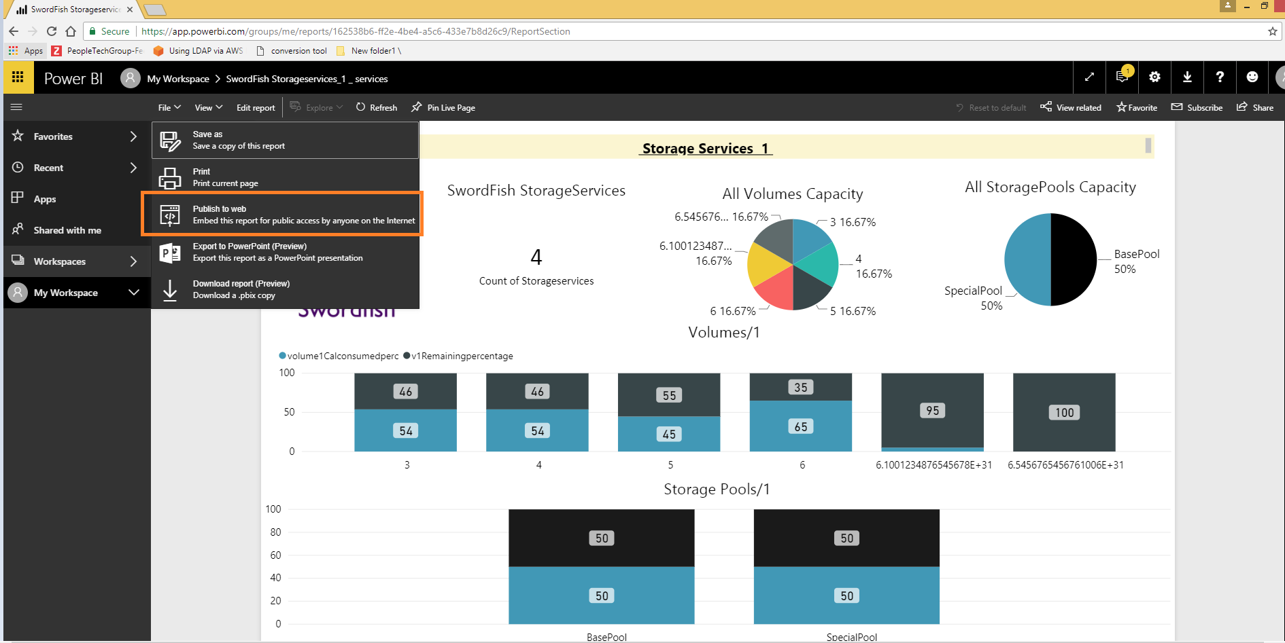

Then it will automatically create one Url we can share those url to any one .